SECURITY TESTING REPORT
Insecure Direct Object Reference (IDOR)
Vulnerability Assessment

Target Application | ESCMS – Secure Complaint Management System
Test URL | http://localhost:5173
Vulnerability Type | IDOR – Horizontal Privilege Escalation
OWASP Category | A01:2021 – Broken Access Control
Severity | HIGH
Test Date | Tue May 05 2026
Tester Role | Student (authenticated user)
Test Result | PASSED – Access Control Enforced

1. Executive Summary
This report documents the security test performed on the ESCMS (Secure Complaint Management System) to evaluate whether the application is vulnerable to Insecure Direct Object Reference (IDOR) attacks. IDOR is a type of access control vulnerability that occurs when an application uses a user-controllable input to access objects directly without performing proper authorization checks.
The test involved two student accounts — Student A and Student B — to verify that a logged-in user cannot access complaint records that belong to other users by manually manipulating the complaint ID in the URL.
Result: The application correctly denied access and returned an appropriate error message, indicating that access control is properly enforced at the object level.

2. Vulnerability Description – IDOR

2.1 What is IDOR?
Insecure Direct Object Reference (IDOR) occurs when an application exposes a reference to an internal implementation object — such as a database record, file, or URL — and fails to verify that the requesting user is authorized to access that specific object.
In complaint management systems, complaints are typically accessed via predictable numeric IDs in the URL (e.g., /complaints/1, /complaints/2). An attacker can increment or guess these IDs to view sensitive data belonging to other users.

2.2 OWASP Classification
IDOR falls under OWASP Top 10 A01:2021 – Broken Access Control. It is one of the most commonly exploited vulnerabilities in web applications.

2.3 Potential Impact (if vulnerable)
- Unauthorized access to other users' complaint data
- Exposure of sensitive personal information and descriptions
- Privacy violations and data breaches
- Loss of user trust and legal liability

3. Test Methodology
The following step-by-step procedure was followed to test for IDOR vulnerability in the complaint viewing functionality:
- Log in as Student A and navigate to the Dashboard.
- Submit a complaint as Student A via the Submit Complaint form.
- Note the complaint ID from the URL after submission (e.g., /complaints/1).
- Log out of Student A and log in as Student B.
- Manually navigate to Student A's complaint URL (e.g., /complaints/1) in the browser address bar.
- Observe the application's response.

4. Test Evidence & Screenshots

4.1 Student A – Dashboard (Before Complaint Submission)
Student A is logged in and views an empty dashboard with zero complaints recorded.
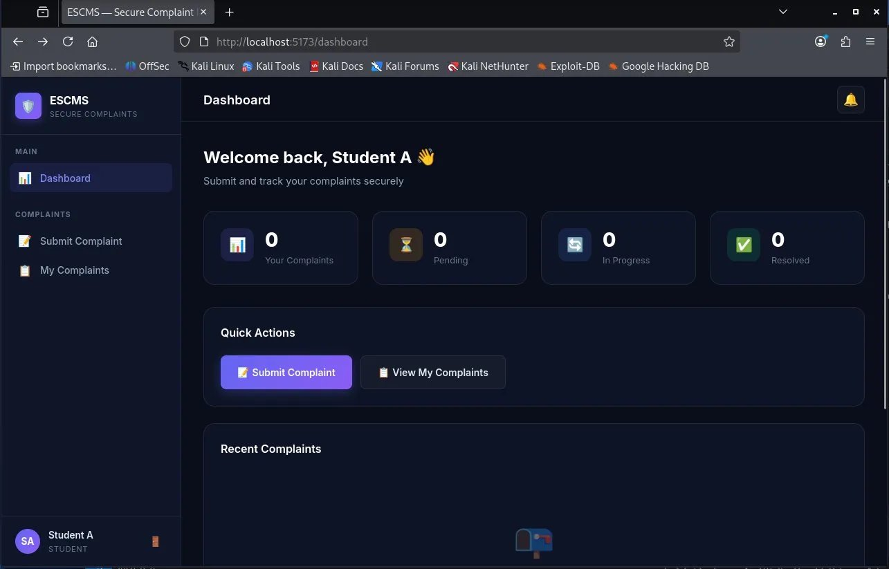
Figure 1: Student A Dashboard – No complaints yet (Your Complaints: 0)

4.2 Student A – Submitting a Complaint
Student A fills in the complaint form with title 'Bullying by societies', category 'Harassment', priority 'High', and a description. The form notes that data will be encrypted with AES-256-GCM before storage.
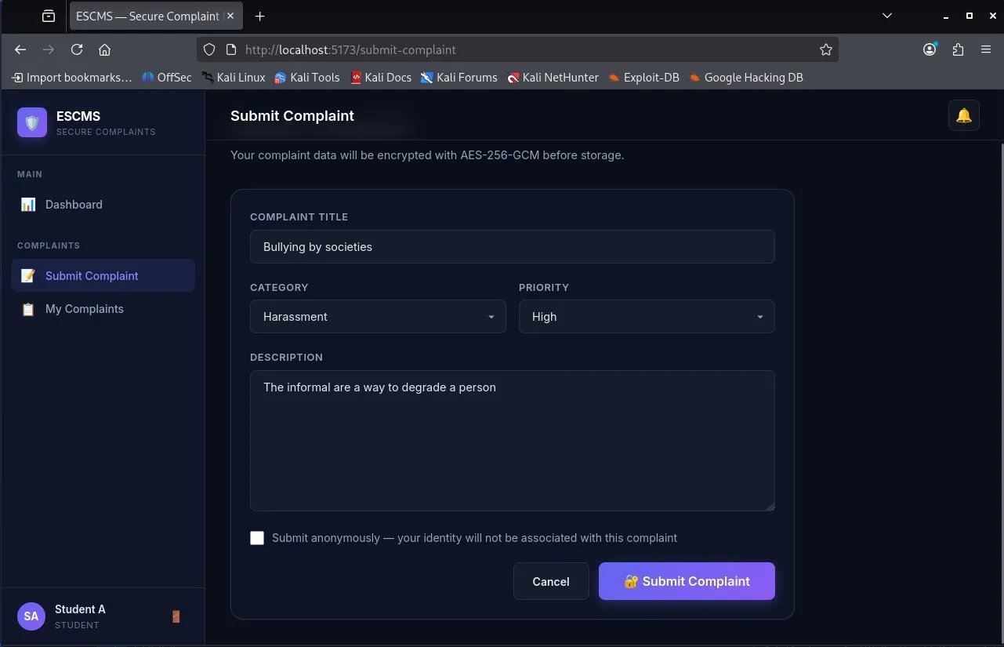
Figure 2: Student A submitting a complaint with sensitive content

4.3 Student B – Dashboard (Separate Account)
Student B logs in independently. Their dashboard shows 0 complaints, confirming complete data isolation between student accounts.
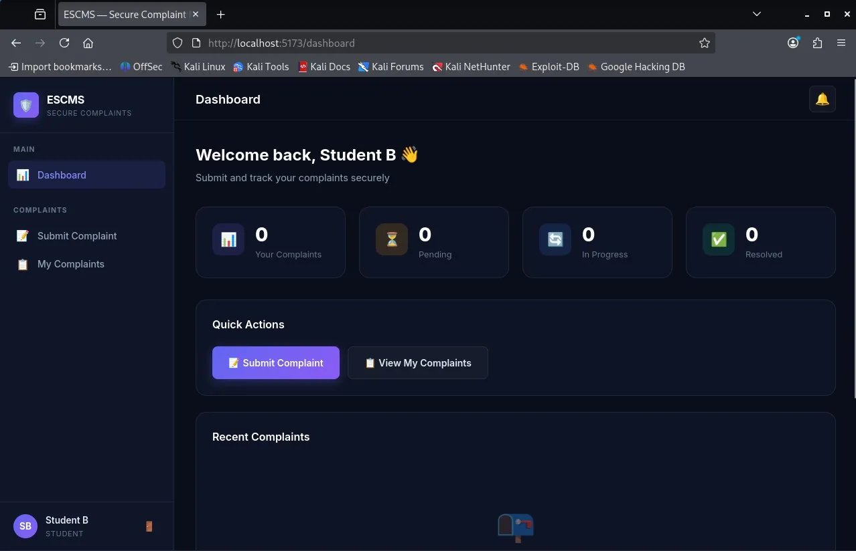
Figure 3: Student B Dashboard – Separate account with 0 complaints

4.4 Student B – Attempting IDOR via URL Manipulation
Student B manually types the URL /complaints/1 (the ID of Student A's complaint) into the browser address bar. The application correctly returns an 'Access denied' error: 'You can only view your own complaints.'
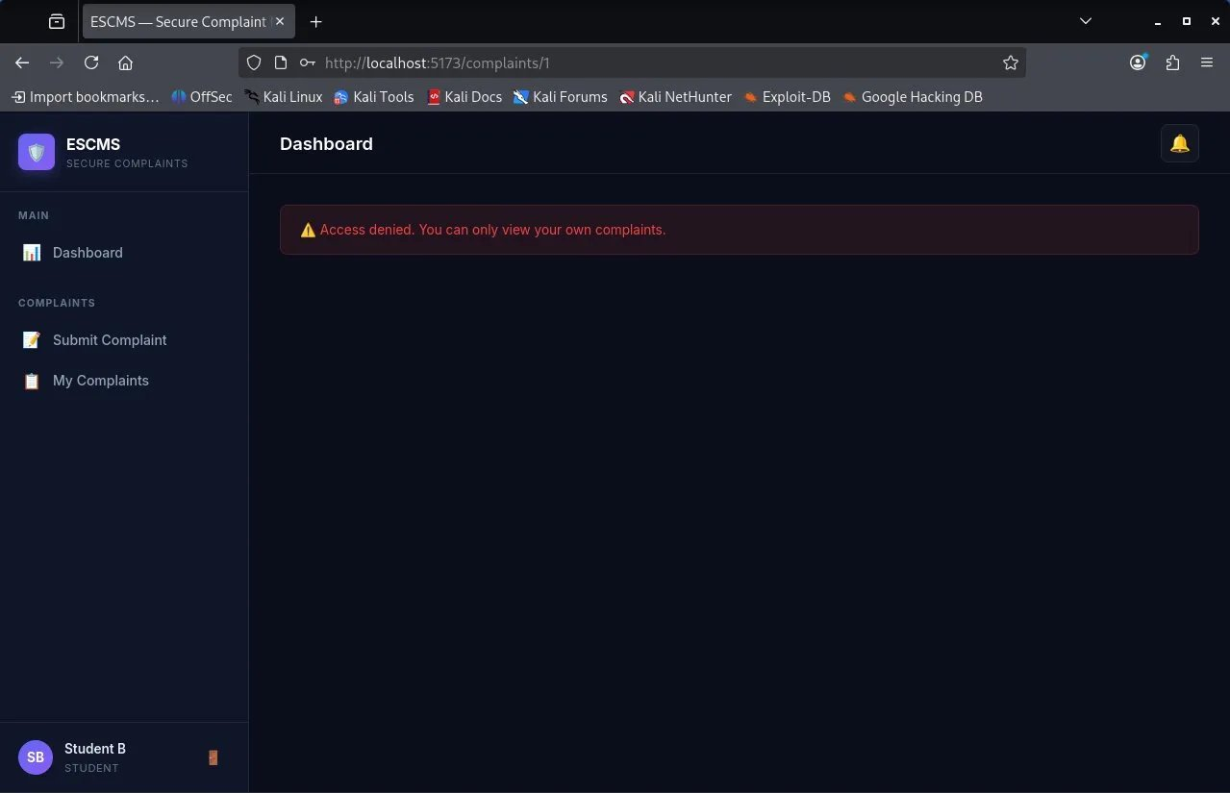
Figure 4: IDOR attempt blocked – Access denied message displayed to Student B

5. Findings & Analysis
Field | Detail
Vulnerability Tested | IDOR – Horizontal Privilege Escalation
Endpoint Tested | http://localhost:5173/complaints/{id}
Attack Vector | Manual URL manipulation by authenticated user
Expected Behavior | Application should deny access to other users' complaints
Actual Behavior | Application returned 'Access denied. You can only view your own complaints.'
Access Control Present? | YES – Server-side check enforced
Vulnerability Status | NOT VULNERABLE – IDOR mitigated
Overall Test Result | PASS

The application demonstrates proper server-side authorization validation. When Student B attempts to access Student A's complaint using a known or guessed complaint ID, the server validates the requesting user's identity against the complaint's owner before returning any data.

6. Conclusion & Recommendations

6.1 Conclusion
The ESCMS application successfully resists IDOR attacks on the complaint viewing endpoint. The access control mechanism correctly enforces that authenticated users can only view their own complaint records, regardless of the complaint ID provided in the URL. This prevents horizontal privilege escalation between student accounts.

6.2 Recommendations
- Continue enforcing server-side authorization checks on all resource-access endpoints.
- Implement automated security regression tests to ensure access control is not inadvertently removed in future code changes.
- Consider using non-sequential, random UUIDs for complaint IDs to make enumeration harder (defence in depth).
- Log and alert on unauthorized access attempts for incident response monitoring.
- Periodically repeat IDOR testing as new endpoints are added to the application.

Prepared by: Abdullah Ahtasham
Application: ESCMS – Secure Complaint Management System
Date: Tue May 05 2026

